**Customizable LED Matrix**

Final Project

Sage Marks and Matthew Krueger

3360:0001 – Embedded Systems

Professor Beichel

University of Iowa, College of Engineering

5/9/25

Table of Contents

1. Introduction 3

a) Motivation and background 3

b) Goals and Specifics 3

2. Implementation 3

a) Overview 3

b) Hardware Description 3

c) Software Description 3

3. Experimental Methods 4

4. Results 4

5. Discussion of Results 4

6. Conclusion 5

Acknowledgements 6

References 6

Appendix – Source Code 6

## Introduction

### Motivation and Background

Our project goal was to build something that will be thrown away - or stripped down to preserve parts - after the class ends. The LED Matrix (and game system) sufficed; it allows for various programs, unique displays, and extendibility beyond this course. Because of the ESP32, this system can be iterated on to support user I/O via a web application. However, that would be more of an IoT project than Embedded Systems... just our thinking. As we are roommates, this system is currently being held in our living room. The Iowa Hawkeye themed system compliments our room nicely.

### Goals and Specifics

The goals of this project were to develop a customizable LED matrix, that can be interacted with by the user. The interaction with this matrix was to be done through buttons, RPGs, and joysticks. The sketch program on the matrix functions similarly to the well-known “Etch A Sketch” game. However, our version mode the user to draw with in full RGB rather than monochrome. Additionally supported at this time is the pixel art mode, where small pixel art can be cycled through using the navigation. Use of the controllers were not fully programmed due to time constraint, so these partial programs were redacted from this submission.

## Implementation

### Overview

### Hardware Description

There was a good deal of hardware that went into the implementation of our customizable LED matrix. The memory required to operate the LED matrix exceeded the amount provided by the Atmega328P. Knowing this fact, we used an ESP32 for all interactions with the LED matrix. The Atmega328P served as a microcontroller that operated with input devices only. This meant that the push buttons, RPGs, and joysticks all were connected to the Atmega328P. All these devices were interrupt-driven besides our power button. Periodically the flags these interrupts set were sent over USART to the ESP32 to be processed. Below is an exhaustive list of all the hardware that was included in our project.

|  |  |  |
| --- | --- | --- |
| Hardware | Quantity | Description |
| Atmega 328P µC  ESP-WROOM-32  Active Low Push Button  Rotary Pulse Generator  KY-023 Joystick module  RGB LED Matrix Panel  Bidirectional logic level converter  1N5189 diode  IRF4905 PMOS  2N222A NPN transistor | 1  1  8  2  2  1  1  2  1  1 | Programmable µC  Programmable µC  Push button for user inputs  Etch A Sketch drawing user input  Joystick for controllers (XY-axis)  LED display  Communication ESP32-Atmega 328P  Power latch circuit- reverse voltage spikes  Power latch switching  Power latch |
| 10KΩ Resistor | 12 | Debouncing and power latch circuit |
| 0.01µF Capacitor | 5 | RPG and push button debouncing |

**Figure 1**: Hardware materials list

------------------------TODO------------------------------------------------------------------------------------------------------------------------------------------------TODO------------------------

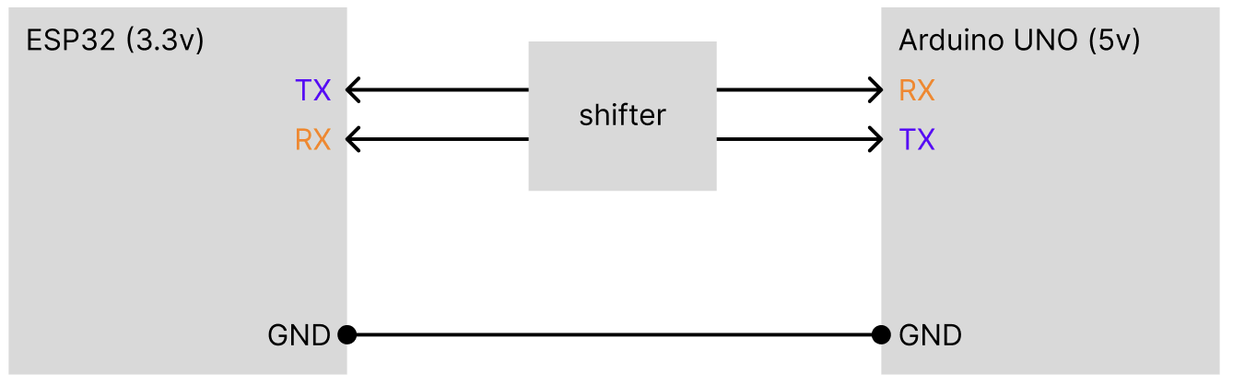

**Figure TODO**: Conceptual diagram of level shifter

The centerpiece of the system is the LED matrix, a 64x64 (4096 individual LEDs) matrix. With so many LEDs, the amount of ram needed to store the pixel information (location, rgb, etc) is too much for the 2KB of SRAM of the ATMega328P. Additionally, the matrix would take up most of the GPIO pins on the board with the 16-line HUB75E interface. This is the reason why the ESP32 is a necessity of this project; it has 512MB of RAM and plenty of pins.

The LED matrix is driven using the HUB75(E) (E is for the additional addressing ABCDE used in larger matrices). There are 16 pins including two grounded pins. At one time, 2 rows are lit with R1B1G1 and R2G2B2 describing the information for pixel values. ABCDE are for addressing. 2^5 = 32 which is one row. This information is latched by LAT, and outputted with OE. This is a synchronized process and thus there is a CLK pin. On our board, there are two HUB75(E) interfaces for chaining multiple LED matrices.

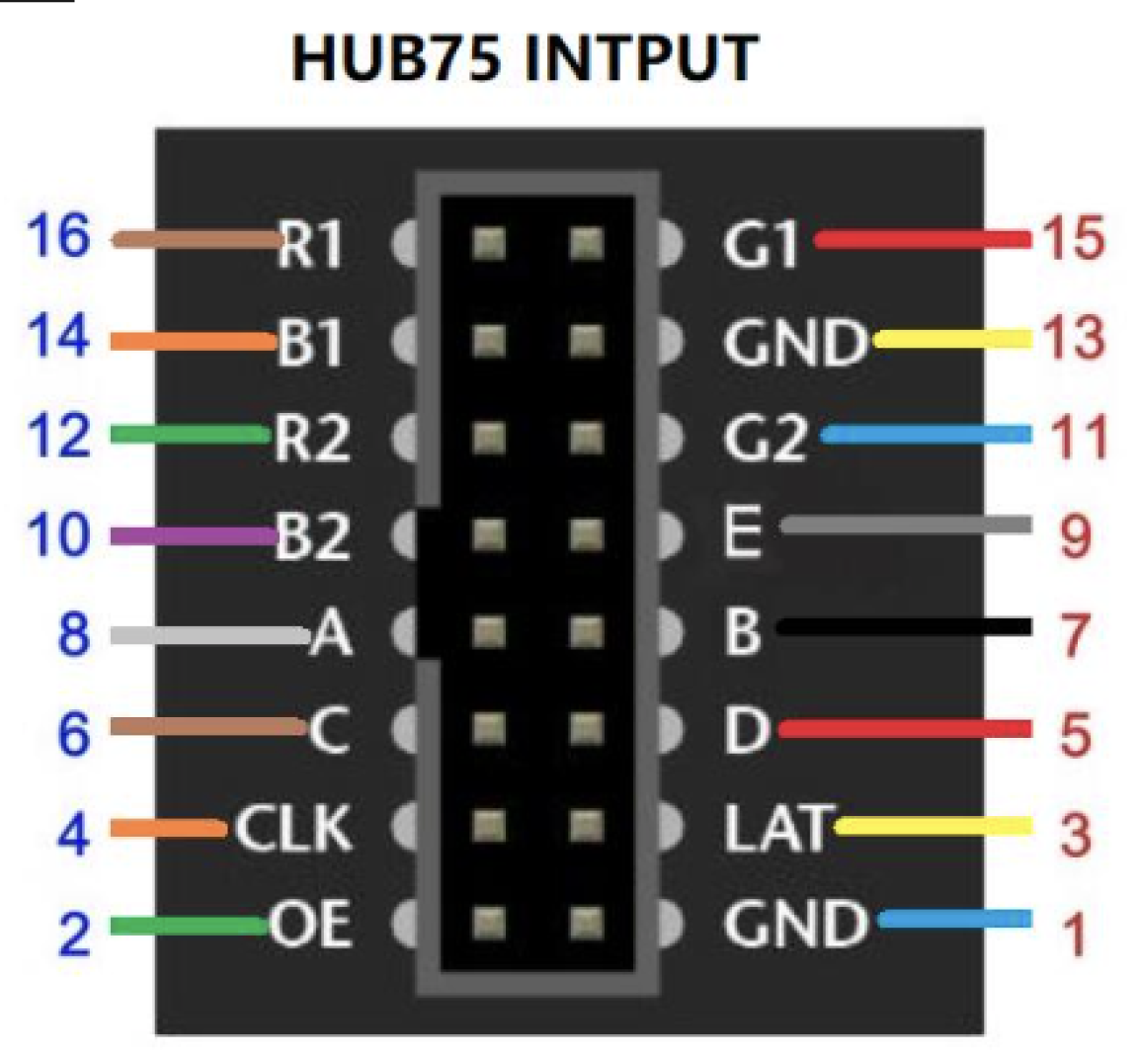

**Figure TODO**: HUB75(E) interface

On the matrix itself are over 30 IC chips. We purchased an off-brand clone of the [Adafruit 64x64 Matrix](https://www.adafruit.com/product/5362) to save money, so the following information is incorrect, but applicable to LED Matrices in general. On our specific board is 24 shift registers, 8 demultiplexers for addressing columns, 3 HUB75E buffer chips, and an additional demultiplexer for addressing rows. This hardware correlates with a 2-row scan, meaning that only two rows oof the LED Matrix are lit at one time. However, with extremely refresh rates and human persistence of vision, the human eye cannot perceive the scanlines.

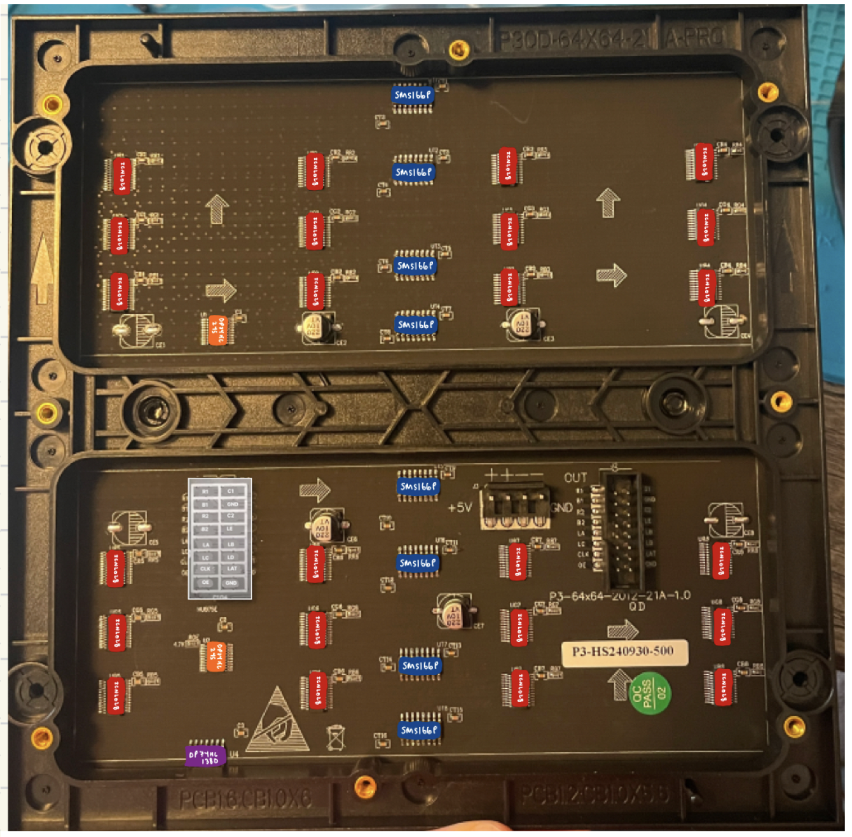

**Figure TODO**: LED matrix ICs & interfaces

### Software Description

With the use of two devices, we divided our project into two programs. The VSCode [PlatformIO](https://platformio.org/) extension made this process easy, allowing to isolate environments (libraries, framework, build dependencies) by device – something which the Arduino IDE does not allow. Below is an exhaustive list of the libraries used by each device

|  |  |  |
| --- | --- | --- |
| Device | Library | Description |
| Atmega 328P µC | [Arduino.h](https://github.com/arduino/Arduino)  [avr/io.h](https://www.nongnu.org/avr-libc/user-manual/group__avr__io.html)  [avr/interrupt.h](https://www.nongnu.org/avr-libc/user-manual/group__avr__interrupts.html) | Required for Arduino setup() and loop() on PlatformIO  GPIO definitions  ISR vectors |
| ESP-WROOM-32 | [Adafruit GFX](https://github.com/adafruit/Adafruit-GFX-Library)  [FastLED](https://github.com/FastLED/FastLED)  [ESP32 HUB75 …](https://github.com/mrcodetastic/ESP32-HUB75-MatrixPanel-DMA) | Core graphics  General Arduino LED matrix driver  HUB75E interface driver |

**Figure TODO**: C libraries list

The ATMega328P contained one main.cpp file. This file contains all functionality of the ATMega328P handling the user input from peripherals and the UART. To improve the performance of the system, interrupts were used for the following:

|  |  |  |
| --- | --- | --- |
| Interrupt Pin (Arduino Pin) | Peripheral | UART String sent |
| PCINT0 (PB0) | Button ‘B’ (Controller 1) | “btnController1B” |
| PCINT1 (PB1) | Button ‘A’ (Controller 1) | “btnController1A” |
| PCINT2 (PB2) | RPG ,1 A (LHS) | “rpg1CW/rpg1CCW” |
| PCINT3 (PB3) | RPG 1, B (LHS) | “rpg1CW/rpg1CCW” |
| PCINT4 (PB4) | RPG 2, A (RHS) | “rpg2CW/rpg2CCW” |
| PCINT5 (PB5) | RPG 2, B (RHS) | “rpg2CW/rpg2CCW” |
| PCINT18 (PD2) | Button ‘Down’ | “btnDownArrow” |
| PCINT20 (PD4) | Button ‘Up” | “btnUpArrow” |
| PCINT22 (PD6) | Button ‘B’ (Controller 2) | “btnController2B” |
| PCINT23 (PD7) | Button ‘A’ (Controller 2) | “btnController2A” |

**Figure TODO**: UART message list

The ‘Home’ and ‘Power’ buttons have multiple functions depending on the duration of the press and hold making interrupts unsuitable for these buttons. Additionally, the joystick XY signals are analog and cannot be implemented as an interrupt. For these signals, traditional polling was used inside of the main loop of the program. This creates a very long file, but the length is necessary as ISRs cannot be created outside of the main file in PlatformIO.

The ESP32 handles the bulk of the system’s functionality, both driving the LED matrix and handling program logic. The source code separates the .h files inside of the ‘include/’ and the .cpp implementations in the ‘src/’. PlatformIO handles the compiling and linkage of these files. The ‘include/’ and ‘src/’ directories are parallel, each including the subdirectories ‘EtchASketch/’ and ‘PixelArt/’. main.cpp resides in ‘src/’.

The main.cpp file of the ESP32 serves to receive the UART commands coming from the Arduino. The strings listed above are matched and mapped to the wanted action. Pairing these actions with a pseudo-state machine (HOME, COLOR_SELECT, EtchASketch, LOGO_DISPLAY… note current naming convention is clunky & not descriptive), the user can control what is being displayed to the LED matrix. The starting screen is set to HOME.

The ‘EtchASketch/’ directory includes files to program the COLOR_SELECT screen/state – which the user sees when selecting the ‘Sketch’ program from the HOME screen menu. Here, the user selects the color which they want to use for the ‘Sketch’ program. Additionally, the user interface is programed such that the user can change the current drawing color by using the ‘Up’ and ‘Down’ arrows.

The ‘PixelArt/’ directory includes a single file that holds the pixel maps for the supported images and methods to cycle through images in a slideshow fashion. To create a single image, a pixel map with each character representing a pixel was stored in a character array. For example, the character ‘B’ represents a black pixel, ‘b’ a blue pixel, and ‘r’ a red pixel. This was a very tedious process and there is opportunity to improve it in the future using AI. There are online tools, however we couldn’t crack how to use them and deduced that because it is such a small matrix, then maybe a tool like this has yet to be designed. More research will be conducted. After creating the array, the characters are scaled to enlarge and displayed row by row to the matrix.

### 3D Modeling

This system was designed to be a minimal viable product or proof of concept for a fun game console toy. 3D models for the frame, button caps, and controllers were created using Fusion360 and printed using a BambuLab P1S 3D-printer. The estimated cost (we saved with filament deals) of the frame was calculated using BambuStudio. A breakdown of these costs and the .stl files can be found inside of our [repository](https://github.com/mattnkrueger/ECE-3360_Embedded_Systems/tree/main/EmbeddedEtchASketch/3d_models).

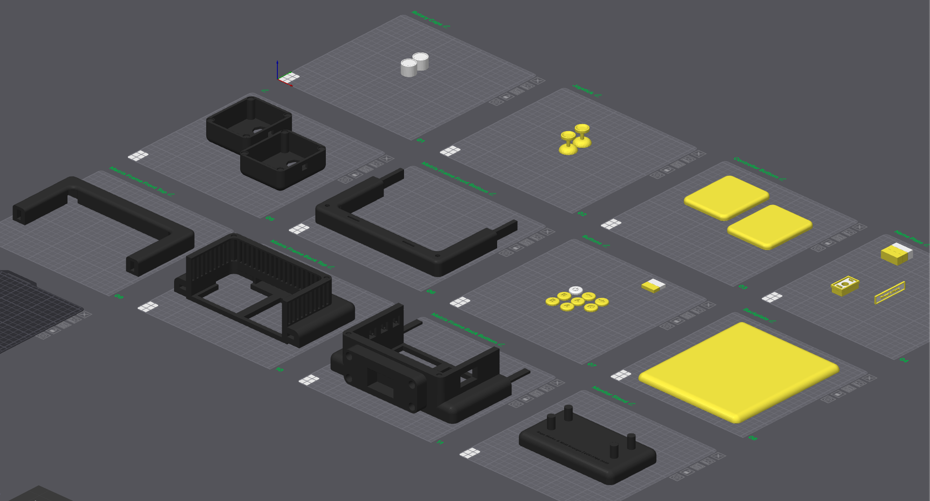

**Figure TODO**: 3D models

## Experimental Methods

## Results

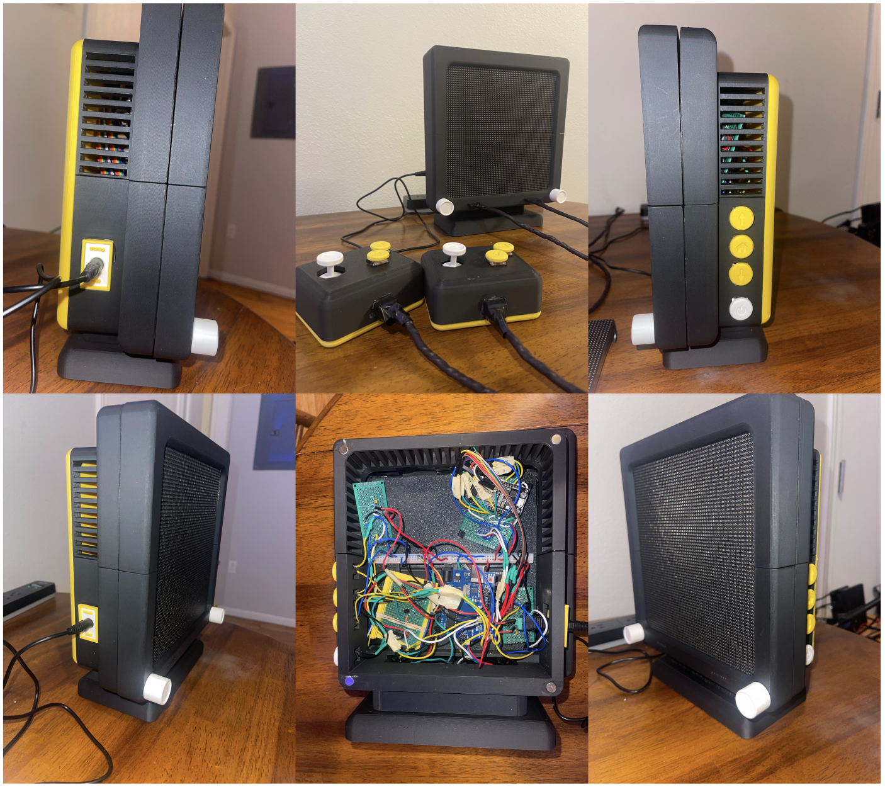

**Figure TODO** : Final product

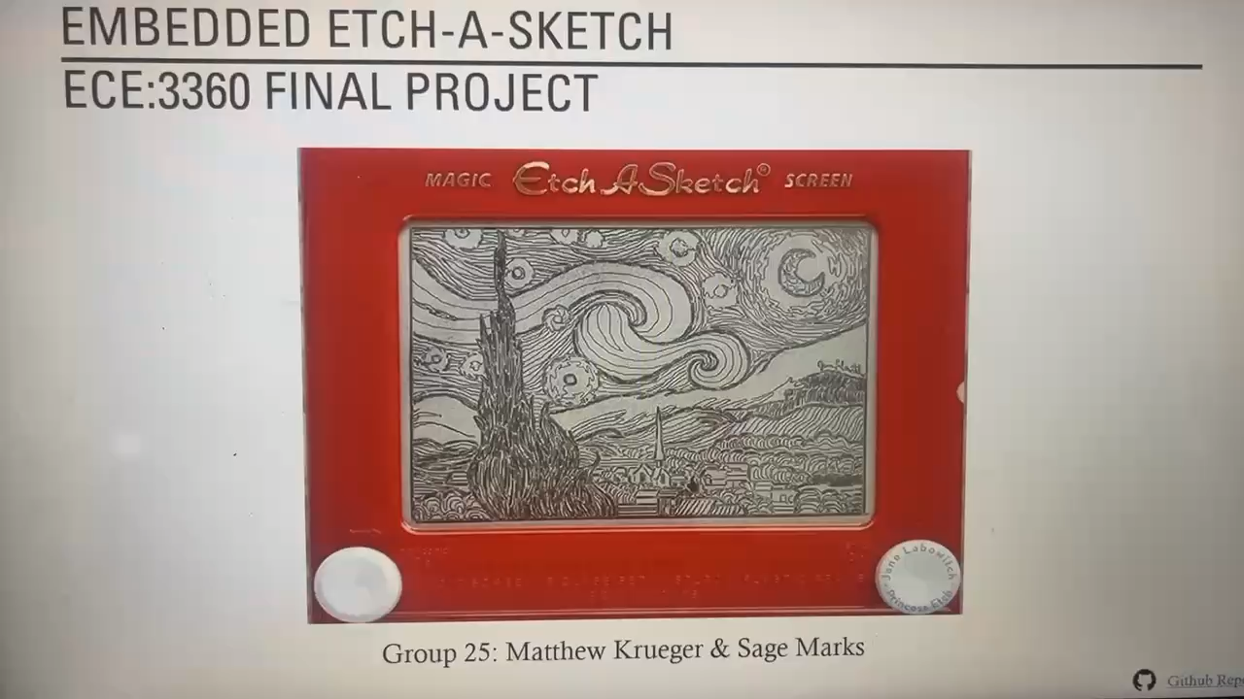

**Figure TODO** : Demo included in [video](https://github.com/mattnkrueger/ECE-3360_Embedded_Systems/blob/main/EmbeddedEtchASketch/project_report/project_video.MOV)

## Discussion of Results

## Conclusion

Ultimately, our design was - and is - predicated on simplicity and ease of use. Its modular frame allows for swappable themes, the simple yet powerful microcontrollers allow for many peripherals, and the intuitive libraries simplify the software overhead. As with any good hardware and software, the design is built to last. The conglomeration of labs resulted in a cohesive system that puts the fun back into engineering. The programs are enjoyable and accessible for users of any age, which is a success in our books.

## Acknowledgements

## References

## ARDUINO. Arduino GitHub Repository. 2025. <<https://github.com/arduino/Arduino>>

ADAFRUIT. Adafruit GFX Library – Core graphics library for Adafruit displays. 2025. <<https://github.com/adafruit/Adafruit-GFX-Library>>

AVR-LIBC. avr/interrupt.h – Interrupt Service Routine (ISR) definitions. 2022. <<https://www.nongnu.org/avr-libc/user-manual/group__avr__interrupts.html>>

AVR-LIBC. avr/io.h – AVR device-specific I/O definitions. 2022. <<https://www.nongnu.org/avr-libc/user-manual/group__avr__io.html>>

CIRCUITSTATE. DOIT ESP32 DevKit V1 Wi-Fi Development Board – Pinout Diagram & Arduino Reference. 2022. <<https://www.circuitstate.com/pinouts/doit-esp32-devkit-v1-wifi-development-board-pinout-diagram-and-reference/>>

FASTLED. FastLED Library – High-performance LED animation for Arduino. 2025. <<https://github.com/FastLED/FastLED>>

ESPRESSIF SYSTEMS. ESP32 Series – 2.4 GHz Wi-Fi + Bluetooth® + Bluetooth LE SoC. Datasheet Version 4.9. 2025. <<https://www.espressif.com/sites/default/files/documentation/esp32_datasheet_en.pdf>>

MRCODETASTIC. ESP32-HUB75-MatrixPanel-DMA – ESP32 DMA-driven HUB75 LED matrix library. 2025. <<https://github.com/mrcodetastic/ESP32-HUB75-MatrixPanel-DMA>>

WAVESHARE. RGB-Matrix-P3-64x64 – 64×64 RGB LED Matrix Panel, 3mm Pitch. 2025. <<https://www.waveshare.com/wiki/RGB-Matrix-P3-64x64>>

## Appendix – Source Code

There are too many files to include in this document. Please refer to our Github page. Additionally, [Doxygen](https://doxygen.nl/) was used to produce a local HTML page with all commented code. To view this page, navigate to ECE-3360_Embedded_Systems/EmbeddedEtchASketch/src/Doxygen/html/ and open the file ‘index.html’

Github repository: <https://github.com/mattnkrueger/ECE-3360_Embedded_Systems>

Doxygen ‘index.html’: <https://github.com/mattnkrueger/ECE-3360_Embedded_Systems/blob/main/EmbeddedEtchASketch/src/doxygenDocs/html/index.html>